**Step-1**

Install Python from any python environment management system (I recommend ***conda***).

If you do not have any prior experience with python environment managers then I would recommend continuing with Java. They can cause unpredictable problems that can take up a lot of time to solve.

**Step-2**

Install a Python IDE (I recommend ***PyCharm***)

**Step-3**

**Start a new project (for the first time)**

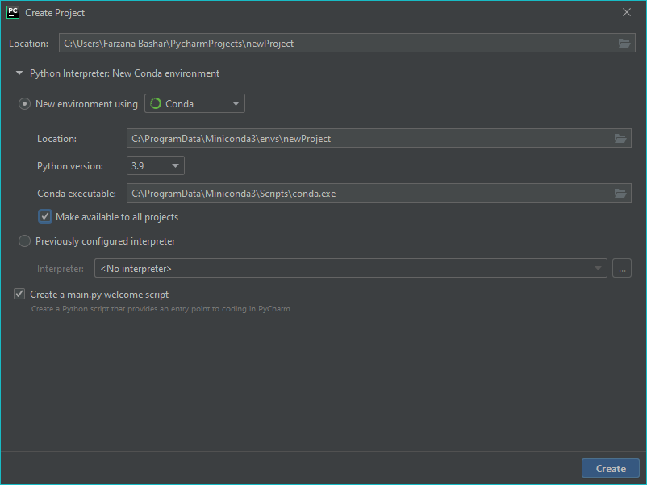

Choose the python environment manager that is in your system.

Tick the “***Make available to all projects***” option. That way you can start from the same virtual environment in the new projects from now on.

Remember the name of the project for later use.

Press the create button.

Now in this virtual environment, we will install OpenGL using the following command.

Go to terminal at the bottom of the screen.

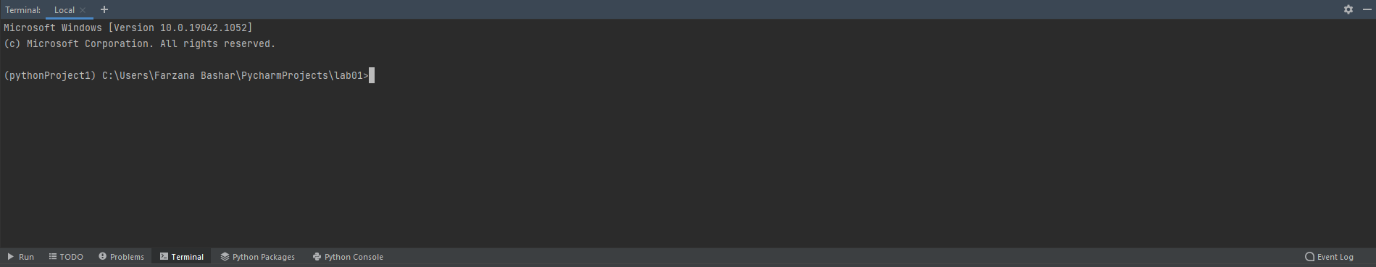

Type the following command.



It will show that PyOpenGL was installed successfully.

So, this virtual environment is set up for OpenGL and if we use this one, we won’t have to install it again.

(Note: Please make sure at least ***Microsoft Visual C++ 14*** or later version is installed or otherwise it will fail)

**Start a new project (Using previously set up virtual environment)**

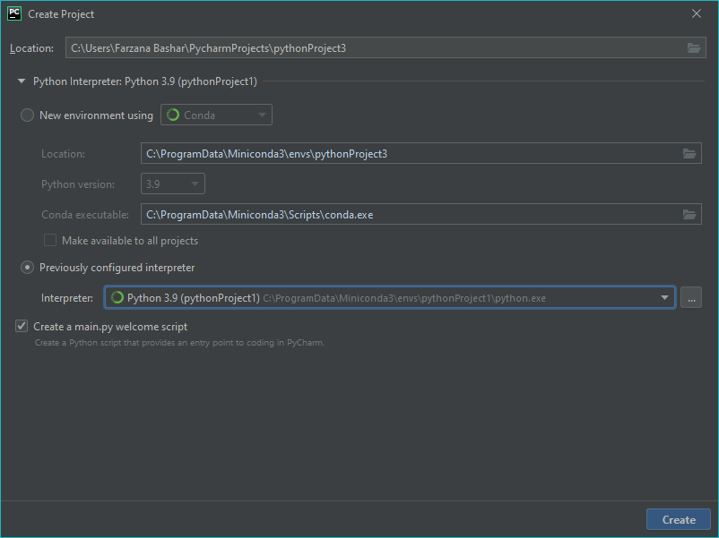

Now use “***Previously configured interpreter***” option. From the drop down you can easily choose your virtual environment.

**Step-4**

Now we have to add the ***FreeGLUT.dll*** file

Download the dll from the following link

<https://drive.google.com/file/d/1rWyJ_MMqy7r99sfWWPkXPkUkLWSqRYBL/view?usp=sharing>

(If you are using x86 architecture please rename it to “***freeglut32.vc14.dll”***

Then, copy this dll to your project alongside “***main.py***”

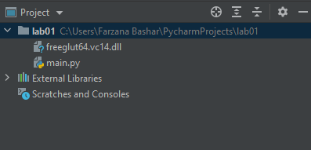

**Step-5**

Copy the template code from the following file

<https://drive.google.com/file/d/1MJt0aeG5CXBQuF7PBolICknYAEpvGayU/view?usp=sharing>

And paste it into ***main.py***

Then, run and you should see a blank screen.

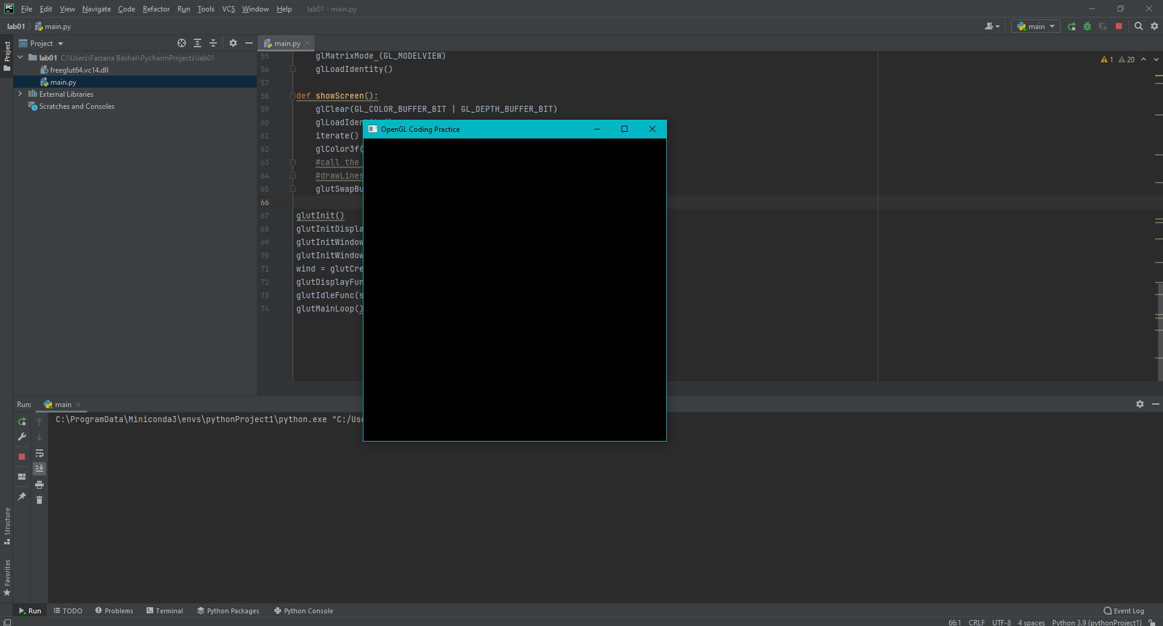

Now go ahead and watch the introductory video.

<https://youtu.be/E09j-bRBC24>

Reference links:

1. <https://stackabuse.com/brief-introduction-to-opengl-in-python-with-pyopengl>
2. <https://stackoverflow.com/questions/27093037/python-glutcreatewindow-error-wrong-type>
3. <https://stackoverflow.com/questions/39181192/attempt-to-call-an-undefined-function-glutinit>